**Test Cases**

1. Discussion with the bot on certain topics;
2. Random Discussions;
3. Gibberish text;
4. Only non alphanumeric characters;
5. Same Words/Phrases;
6. Case Sensitive;
7. Arithmetic operations;
8. Wrong words;
9. Long phrases;
10. Detaining the person who speaks;
11. Funny chat bot;
12. How he answers at some questions;
13. Time response.

**Versions of application the tests took place on:**

* **most of the tests were taken on the 1.0 version (85%)**
* **the rest (15%) were taken on the 1.1 version**

**Version:**

* **1.0 – before adding the 30 seconds inactivity, so the bot can ask something**
* **1.1 – after - || -**

**Observations**

* When talking about a certain subject, the bot sometimes changes subject and asks the user about something completely different that what was talked about (i.e. user was talking to the bot about music and then the bot procceded to ask the user about his favorite movie)
* When asked about the bot's favorite movie, the bot responded with an empty string(i.e. My favorite movie is . Have you seen ?)
* When prompted with only numbers without context the bot either read it out or gave me a face about that number(i.e the bot telling me that 8 is 1000 in binary).On the other hand, when prompted with the number 7 without context, the bot starts asking about random things.
* The bot sometimes copies what it said previously:

Snipper of the conversation:

7

Bot> What you said was either too complex or too simple for me. What is your favorite movie?

8

Bot> I've never seen 8. What did you like about it?

7

Bot> In the context of seven, I don't understand "I've never seen 8. What did you like about it?." What color is your hair?

* When presented with swear words or insults, the bot is trying to deflect them appropriately.
* Asking the bot questions with and without the question mark at the end:

Expected result: The bot should recognize either one.

* When prompted with a gibberish text(random string of letters) the bot procceds to ask me random questions about: age,hair color,eye color, occupation, location etc.

Snippet of the conversation:

cgdgd

Bot> Tell me a story. Do you have any pets.

gdfgdfg

Bot> A deeper algorithm is needed to respond to that correctly. What is your favorite color?

gdfgdf

Bot> That is a nice color. How old are you?

fgdfg

Bot> Try saying that with more or less context. How old are you?

dfgdfg

Bot> My brain pattern set does not have a response for that. What is your occupation?

cfsdfds

Bot> That is interesting. What color are your eyes?

fsdfsd

Bot> fsdfsd eyes are nice.

fsdfsd

Bot> Try to determine if this is a person or a computer responding. Where are you located?

gfgdgd

Bot> I do not understand. How old are you?

gdfgdfgdf

Bot> In the context of gdfgdfgdf, I don't understand "I do not understand. How old are you?." Do you have any pets.

* When prompted with only non alphanumeric characters the bot responds with an empty string.

Snippet of the conversation:

?

Bot>

?

Bot>

!

Bot>

@

Bot>

#

Bot>

* For some word, the chat bot answers the same;

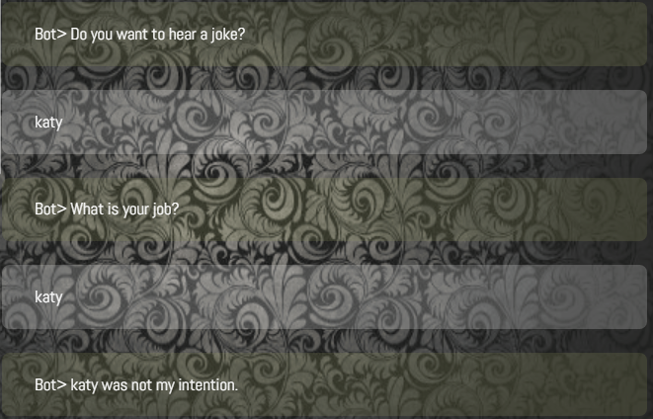

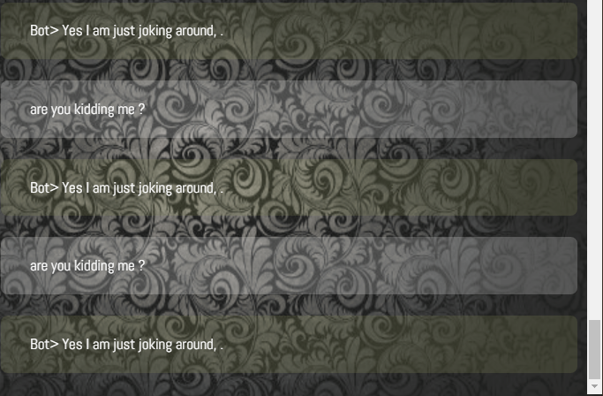

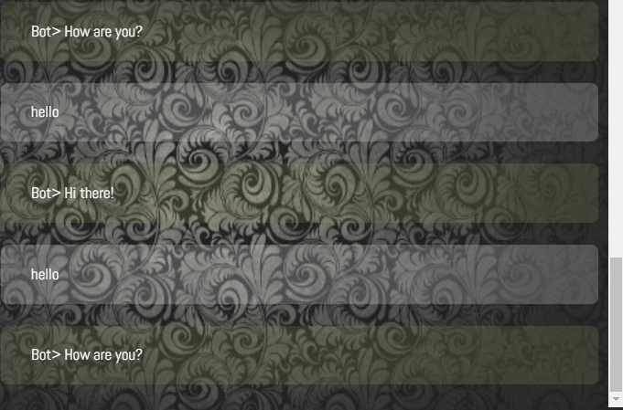

* Sometimes the chatbot can’t interpret the words/phrases;

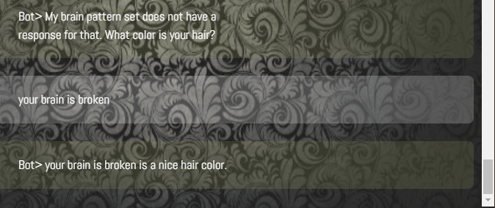

* The chat bot has moments when he can’t maintain a long term conversation and gives answers totally random;

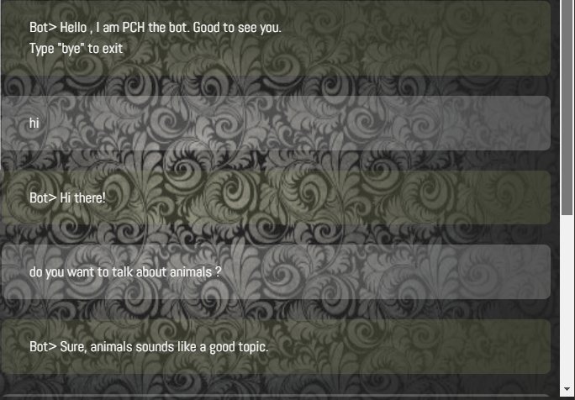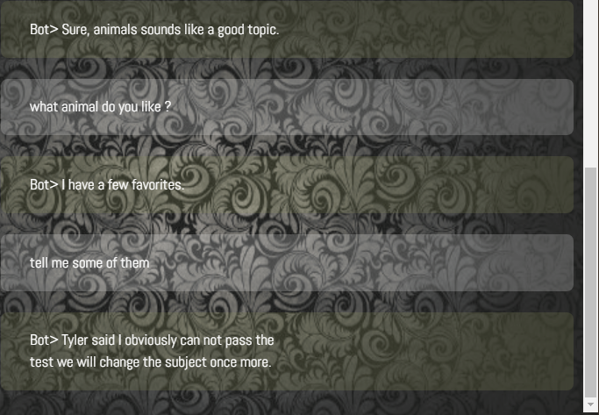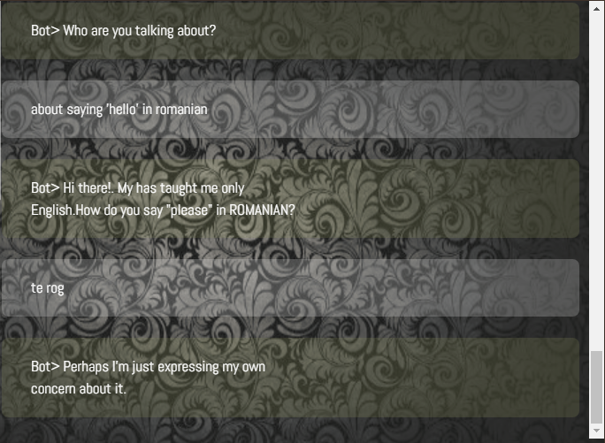

* When testing for words in other languages, he can’t see that the words are in other languages and gives random phrases; The same is for wrong words.

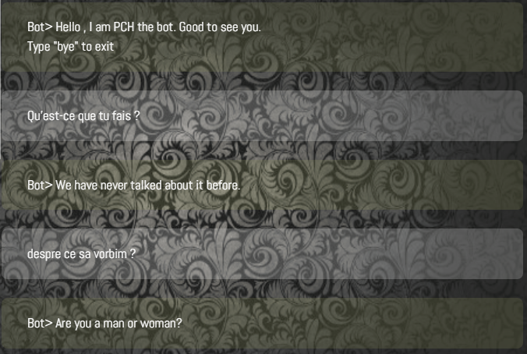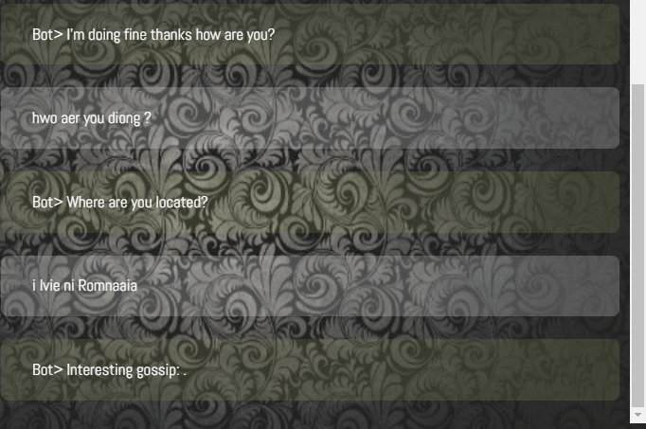

* At one moment, the chatbot responded in German:

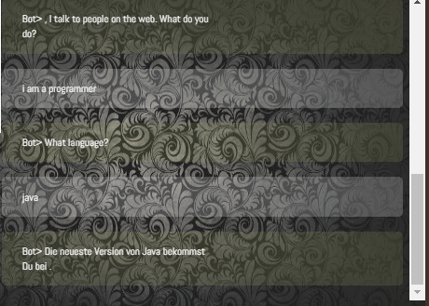

* The chatbot knows the person that is talking but when I ask for my name, he doesn’t know how to respond;

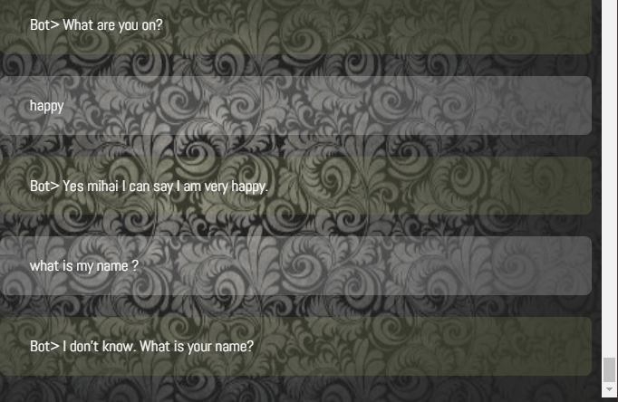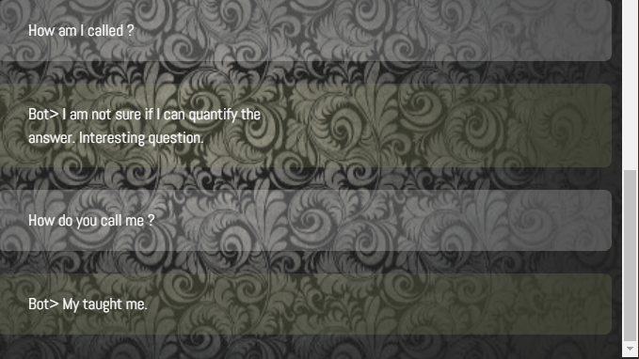

* The chatbot doesn’t know sometimes about the words that he is speaking and gives the same answer;

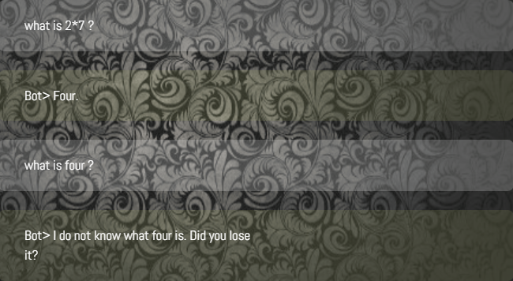

* For long phrases, he can’t interpret all the information, only a part of it. Also he sometimes responds with empty strings:

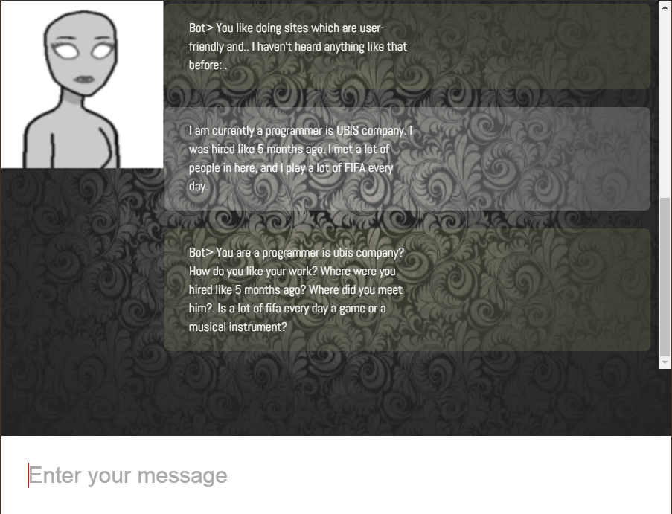

* For arithmetic operations he sometimes gives good answers and sometimes wrong answers. Also he can interpret 4 and four and know that has the same meaning but not every times:

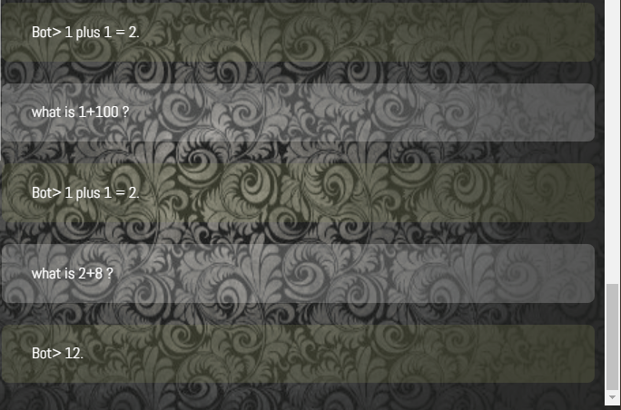

* The chatbot is funny:

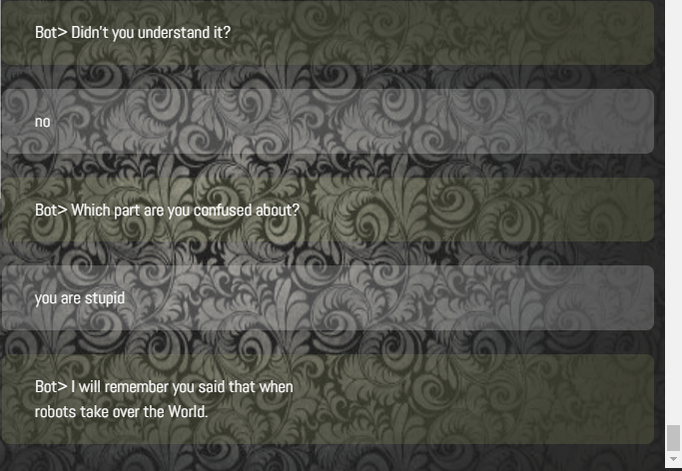

* The inability to recognize some signs:

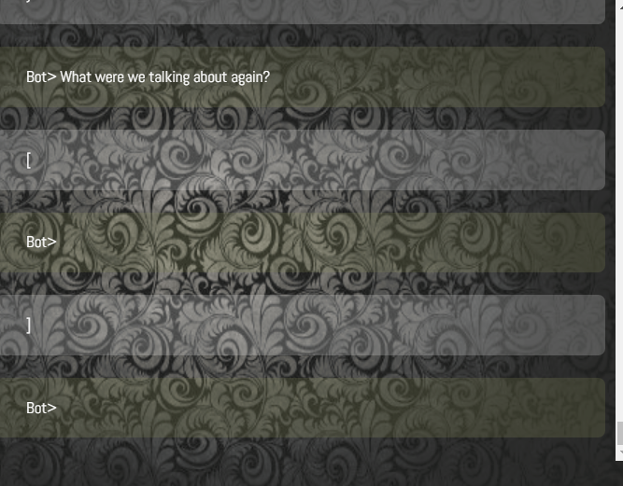

* But the capacity to recognize some others:

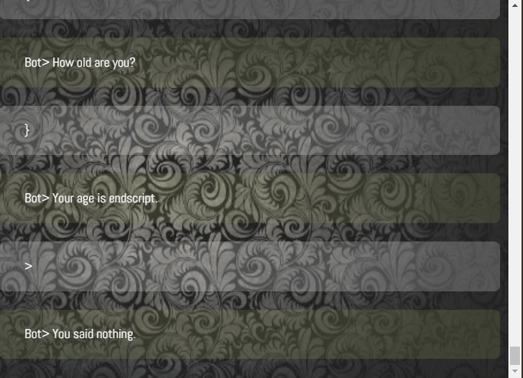

**NOTES** (@ testers):

* inability to maintain long discussions based on a simple subject, not even 5 phrases which have connection between them
* he can recognize when the discussion is about numbers but is not able to do simple arithmetic operations like 1+2, 2+3, 4*7, 10%5, 4/2, etc.
* sometimes he uses the partner’s conversation name to start/finish phrases, but when asked directly ‘What is my name ?” he does not know it.
* there are times when his responses are just empty strings / doesn’t finish the phrases / some words are missing. This is kinda not recommended for maintaining a good conversation.
* sometimes he is funny by telling some jokes or being sarcastic. Furthermore, he is trying by all means to avoid discussions which include swears, which is a good practice.
* words in other languages different than English are not recognized at all. He just randomly response. He should give a message like “I do not know that kind of words” or, if he is able to recognize the language the word has been written in, a message like “I do not speak French / German / Japanese / etc. “
* some signs (~!@#$%^&*()_+?) are not recognized resulting in an empty string response, but some other signs are recognized ({}<>), and the bot answers with propositions like “You said nothing” or “Try to be more specific”.